For Immediate Release Contact:
1/9/25 Carrie Sanders – Executive Director carrie@cherokeestripcf.com
580.234.3988
CSCF hits $900,000 given in Community Investment Program Grants
Enid, OK, January 9, 2025 - The Cherokee Strip Community Foundation (CSCF) is honored to announce awards totaling $150,000 in grants from the Three Corners Connector Community Investment Program (CIP) to nonprofit organizations in Northwest Oklahoma in its fifth round of grants. This distribution, in addition to other donations made by Three Cornes Connector through CSCF totals more than $900,000 in Texas and Cimarron counties.
These grants are part of a broader effort involving multiple stakeholders working together to help residents of Texas and Cimarron County thrive. A Community Advisory Committee, consisting of a diverse group of leaders and residents from Cimarron and Texas County, reviewed grant applications and recommended awards to those projects and programs that would have the greatest impact.
Grant Recipients
Texas County
Texhoma Public Schools: Awarded $1,225 for national tournament entry fees, lodging, meals, and performance materials for the Speech Team.
Panhandle Services for Children: Received $5,000 for mileage and staff time to schools in the area for youth and family counseling.
NW Domestic Crisis Services: Granted $20,000 for legal representation for victims of violence and to support the domestic violence shelter in Guymon.
Main Street Guymon: Awarded $10,000 to support essential repairs and energy-efficient updates to the historic downtown facility.
Loaves and Fishes Food Cupboard of Guymon, Inc.: Received $15,000 to purchase food and supplies for the local emergency food pantry.
Tyrone Oklahoma Volunteer Fire Department: Granted $20,000 to replace bunker gear, upgrade rescue equipment, and add battery-operated equipment.
Kids Inc. of Guymon: Received $8,500 to purchase a second air conditioning unit and duct work in the community gym. Guymon Community Enrichment Foundation: Granted $10,000 to provide homemade meals seven days a week through their dining room, carry-out, or delivery.
Cimarron County
Boise City Fire Department: Received $9,472 to assist in building a Ford-550 brush truck to replace a 1970 model.
The Boise City Recreation Foundation: Granted $8,803 for maintenance at the municipal pool.
Cimarron County Sheriff’s Office: Awarded $19,000 to purchase repeaters for the EMS radios with Cimarron County EMS District.
Cimarron County Emergency Management: Awarded $15,000 to purchase a side-by-side for rugged and remote terrain.
Cimarron County EMS District: Granted $8,000 to purchase 700mhz radios for better communication in remote areas.
“The Cherokee Strip Community Foundation and Three Corners Connector Community Investment Program are dedicated to supporting these wonderful community organizations by funding crucial services, updates, and equipment,” said Carrie Sanders, Executive Director of Cherokee Strip Community Foundation. “CSCF is honored to work together with donors to support these nonprofits, building stronger communities across Northwest Oklahoma.”
The first CIP grant round began in December 2024, awarding $300,000. Since that time, each fall and spring cycle has funded $150,000 to the communities in Texas and Cimarron counties, bringing the total investment in the Oklahoma Panhandle to over $900,000. Three Corners Connector has also funded additional services, bringing their total investment in the region to over $1 million.
For further information about these grants or upcoming grant application cycles, contact Carrie Sanders at the Cherokee Strip Community Foundation at carrie@cherokeestripcf.com or 580-234-3988.
###

About Grid United: Grid United is an independent transmission company aiming to develop next-generation energy infrastructure to create a more resilient and efficient electric system to the benefit of all consumers. For more information, visit www.gridunited.com.

About Three Corners Connector: Three Corners Connector is an up to 300-mile, 525-kilovolt high voltage direct current transmission line connecting the existing electric systems near Pueblo, Colorado and the Oklahoma Panhandle, providing a valuable link between the U.S. eastern and western electric grids. Three Corners Connector will be open to all sources of electrical power generation and will be able to transport power in either direction along the line.

About the Foundation: The Cherokee Strip Community Foundation (CSCF) is an Oklahoma 501c3 tax-exempt organization created by and for the benefit of those in the Cherokee Strip region. CSCF administers over 315 charitable funds that benefit Northwest Oklahoma in many unique ways, through their Enid-based office.
Carrie Sanders – Executive Director – Cherokee Strip Community Foundation – 580.234.3988
Allison Seigars – Program Officer – Cherokee Strip Community Foundation – 580.234.3988

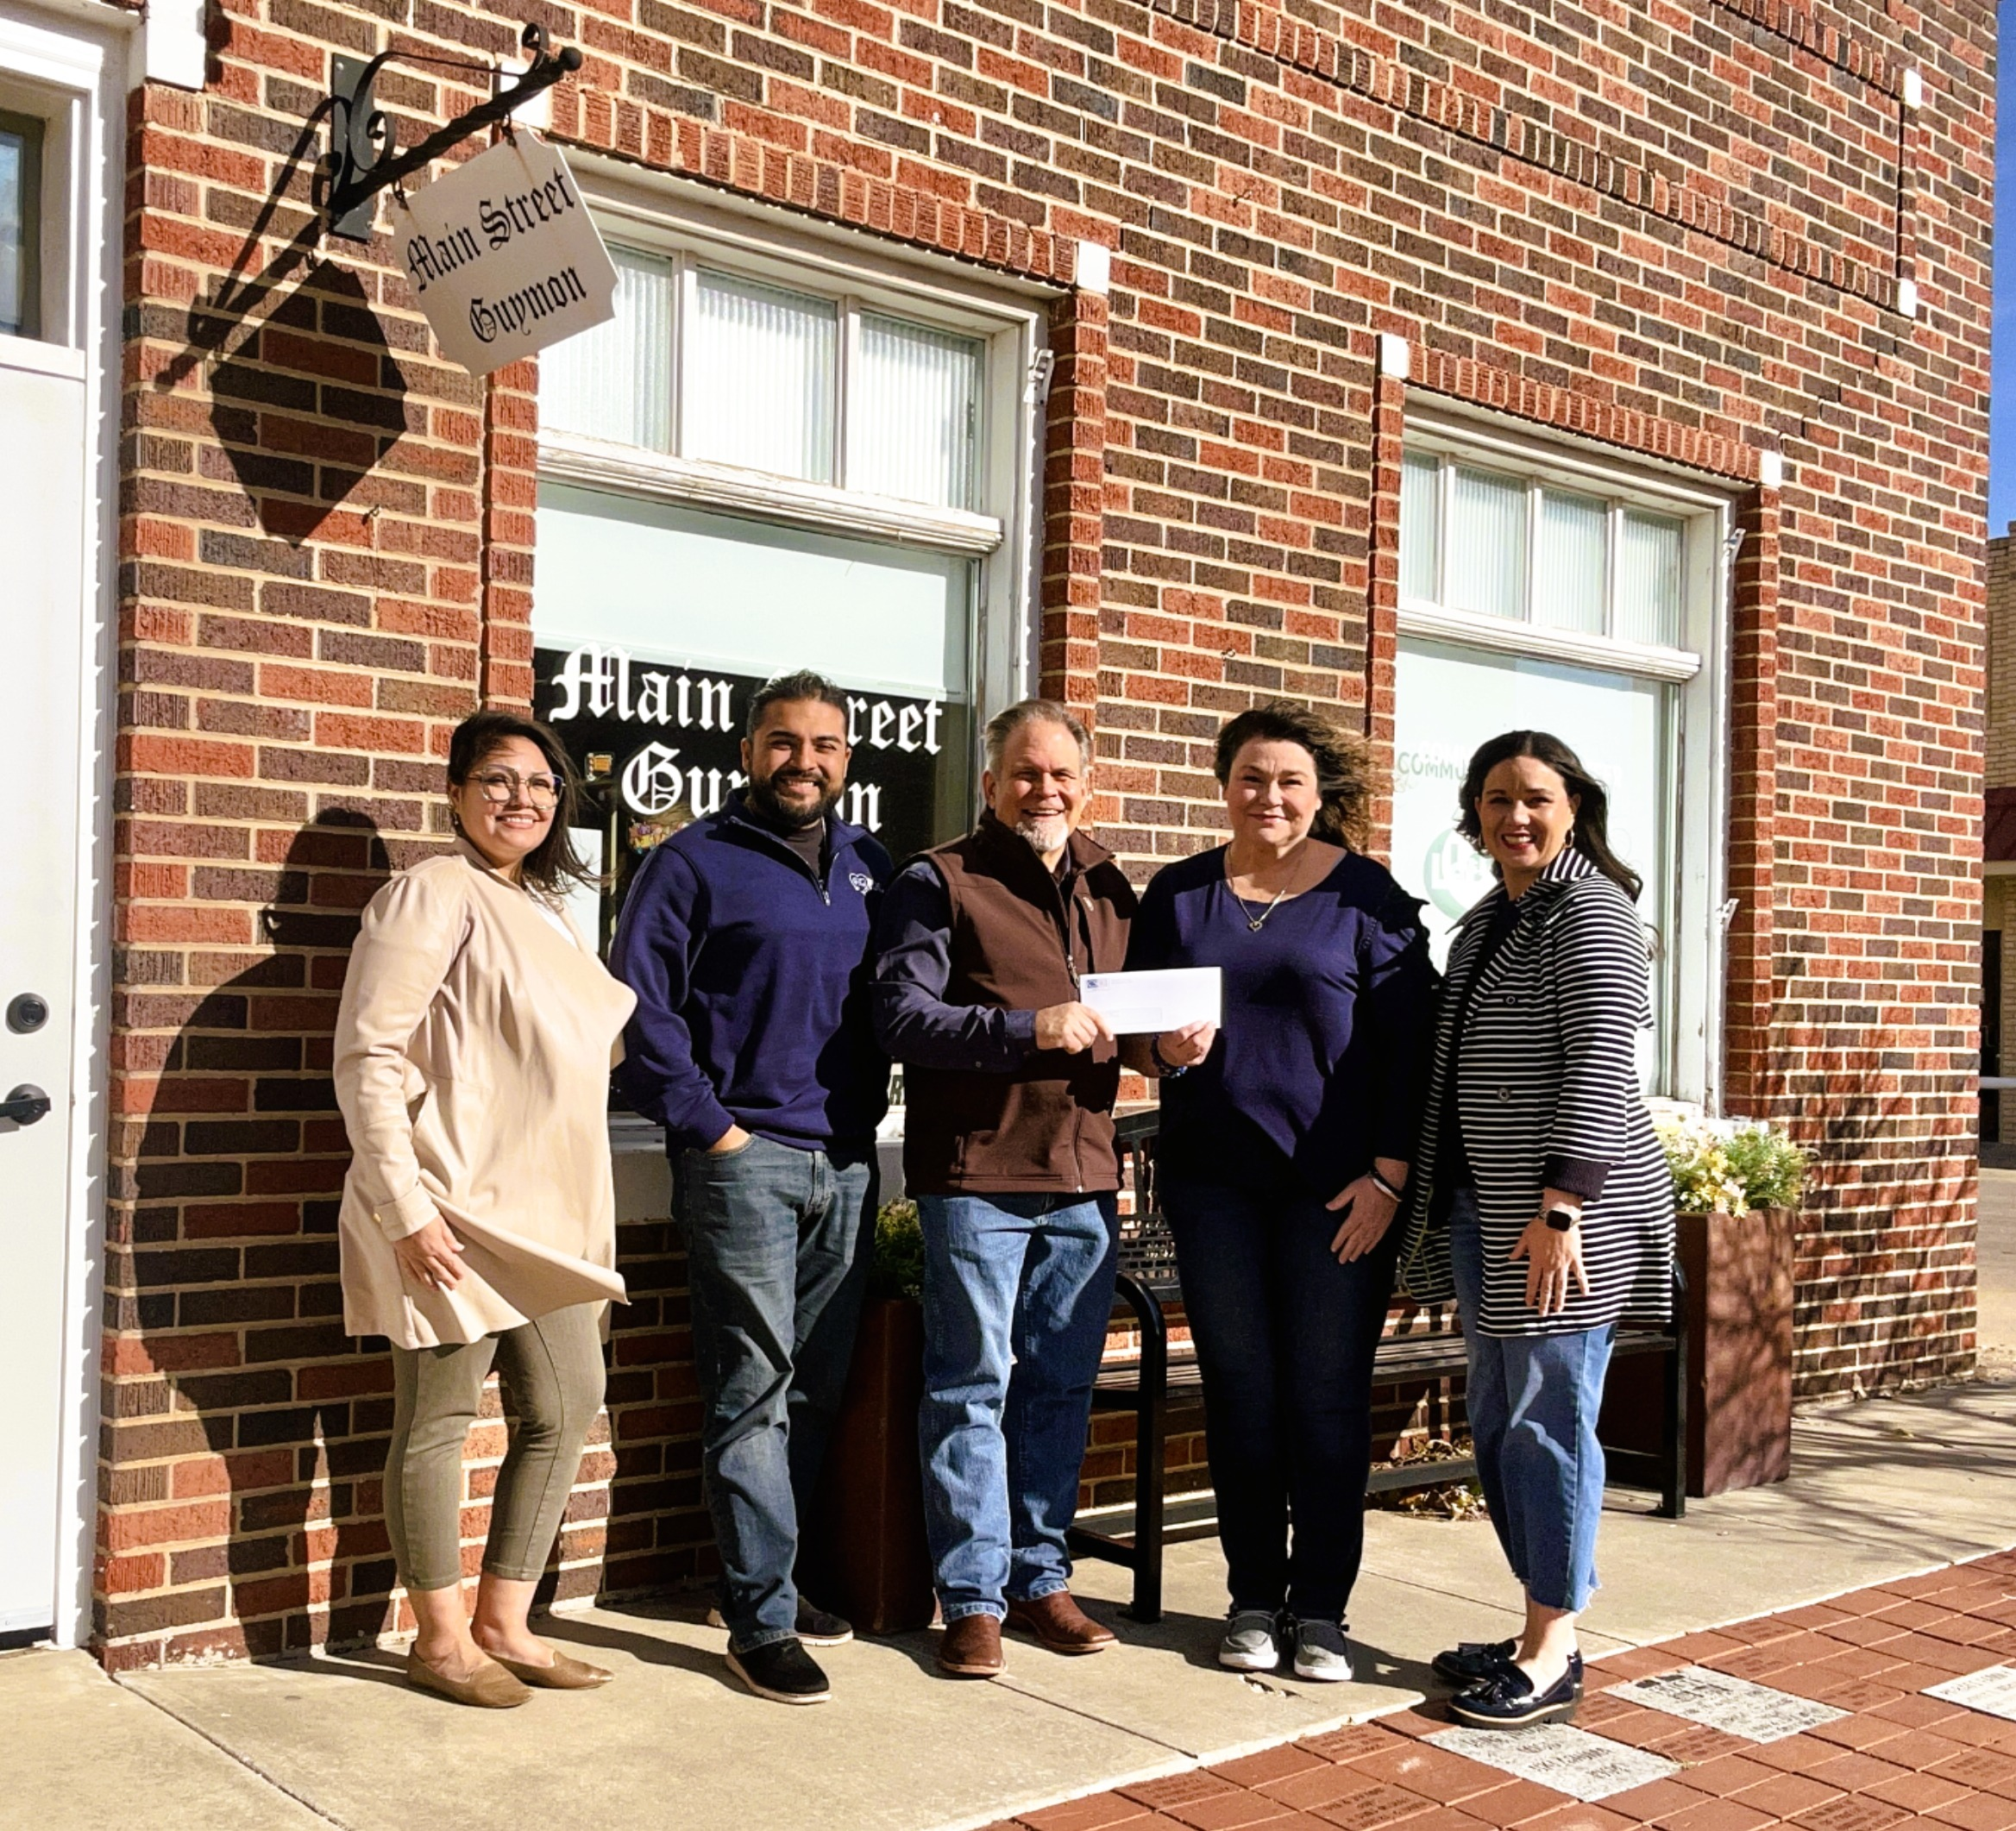

Caption: Sheila Martin (left) and Jose Jauregui, Main Street Guymon Board Members, pose as Alan Manning (center), Three Corners Connector Project Communications Specialist, and Carrie Sanders (right), Cherokee Strip Community Foundation Executive Director, present a check to Ronni Willison, Main Street Guymon Executive Director. The funding will support essential repairs and energy-efficient updates to the historic downtown facility.

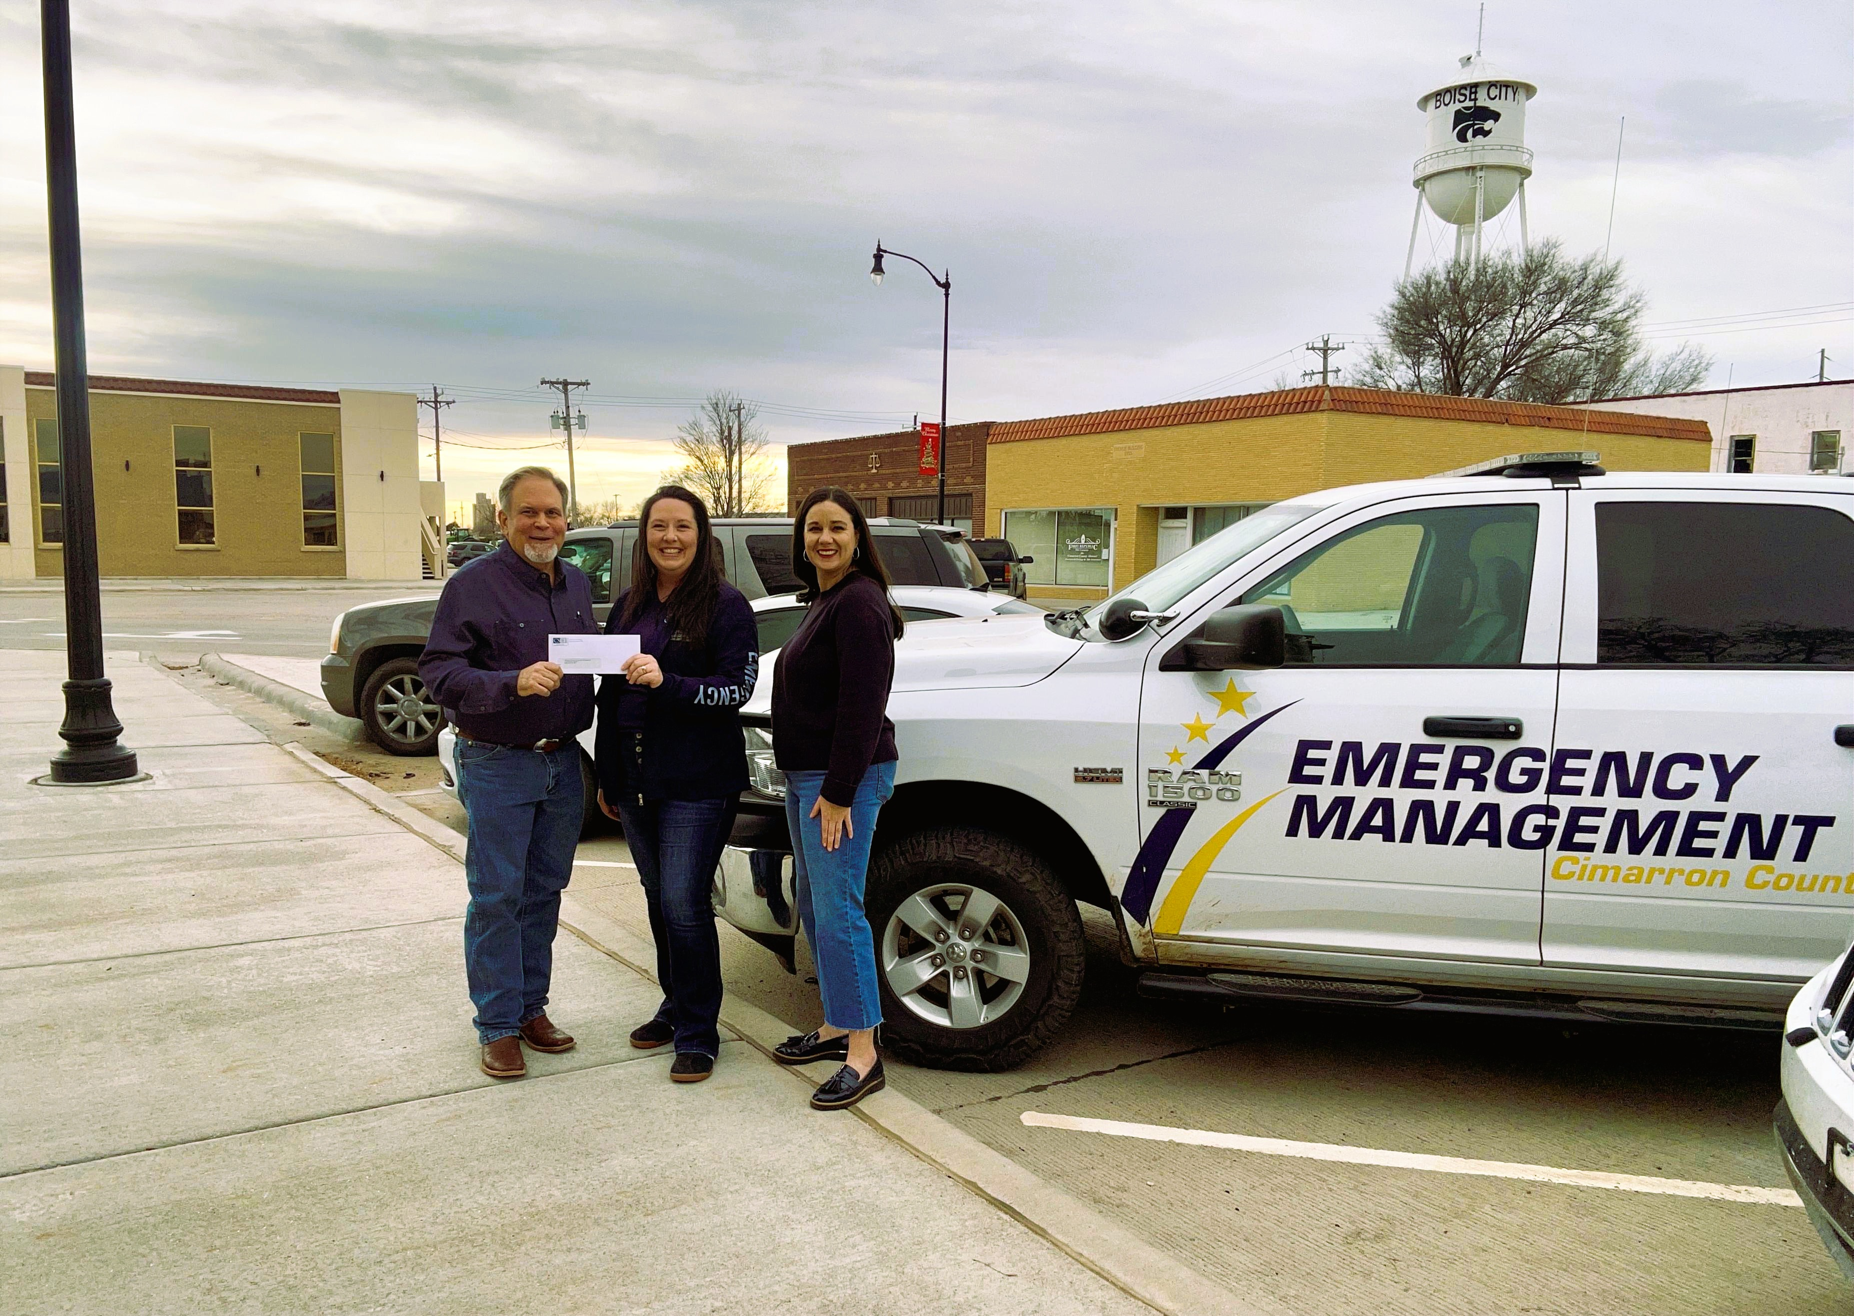

Caption: Alan Manning (left), Three Corners Connector Project Communications Specialist, and Carrie Sanders (right), Cherokee Strip Community Foundation Executive Director, present a check to Lea Lavielle (center), Cimarron County Emergency Management Director. The funding will purchase a side-by-side for rugged and remote terrain.

