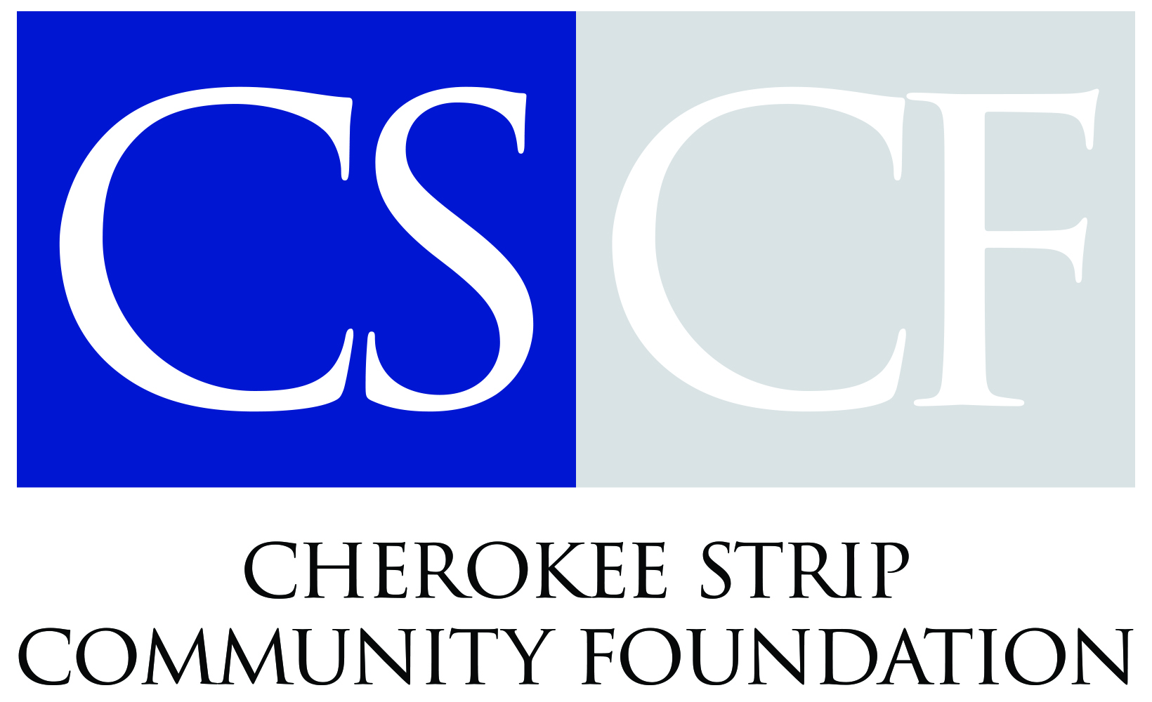

December 10, 2025
Carrie Sanders – Executive Director
580.234.3988 – Office
carrie@cherokeestripcf.com

FOR IMMEDIATE RELEASE:

CSCF awards 13 regional nonprofits with grant distribution
The Cherokee Strip Community Foundation’s (CSCF) Board of Directors is proud to announce 13 recipients of our 2025 annual competitive grants cycle. The grant funds come from several endowment funds administered by CSCF. Each year the CSCF Grant Selection Committee reviews many submissions and balances the applications with community needs, requests, and equitable distribution of funding over the organization’s 13-county area. This year, the committee selected 13 nonprofits that serve residents of Northwest Oklahoma to receive grant funds from CSCF. The grants totaled $65,341.83. Each grant project is unique and will benefit a number of citizens in Enid and Northwest Oklahoma.
The following grants were awarded:
Catholic Charities – The funds will provide case management, counseling, and emergency assistance through their Enid office.
D-DENT (Dentists for the Disabled & Elderly in Need of Treatment) – The grant funds will provide restorative dental care to low-income, uninsured, and disabled individuals in Garfield and surrounding counties.
Families Helping Families / The Hope Center - The funds will purchase a pallet scale to eliminate weighing individual boxes to increase efficiency in the Woodward area.
Girl Scouts of Western Oklahoma – The funds will provide financial aid for members, troop experiences, and recruitment expenses for services in Northwest Oklahoma.
Great Expectations Foundation - The funds will be used to send a Longfellow Middle School teacher to the Great Expectations Institute to learn about the program.
Loaves & Fishes NW OK - Funds will purchase nutrient-rich foods, dairy, and produce for the food and resource center in the Enid area.
Marland’s Place - Funds will be used to assist in building four tiny homes for young adults aging out of foster care or who are housing insecure in the Ponca City area.
New Emergency Resource Agency, Inc. – The funds will provide holiday meals for 165 families and purchase technology for distribution in the Ponca City area.
Oklahoma Dental Foundation – Funds will assist with Oklahoma Mission of Mercy (OkMOM), a free, two-day dental clinic to be held in Enid on February 6-7 at the Stride Bank Center.
Oklahoma Project Woman – Funds will provide no-cost breast healthcare to patients in Garfield County.
On Stage Woodward – The funds will expand youth-centered productions, educational programs and arts opportunities in the Woodward area.
Parents Helping Parents – Funds will provide educational materials and resource guides for families affected by substance abuse in northwest Oklahoma.
The Salvation Army - Funds will provide utility assistance to those in need in the Enid area.
The annual competitive grant cycle at the Cherokee Strip Community Foundation welcomes proposals each September from any non-profit organizations that benefit residents in Northwest Oklahoma. The Foundation will consider funding special projects, innovative programs, and equipment. Most grants range from $1,000 to $10,000. Larger grant requests could be made on occasion.
“We are pleased to offer funding to these amazing organizations who do so much in Northwest Oklahoma,” said Hallie Caldwell, Grant Committee Chair and CSCF Board Member. “The grants help carry out the community foundation’s mission by connecting endowment proceeds with community needs.”
“This will definitely help families in need,” said Phyllis Haines at the Salvation Army in Enid. “Winter is a difficult time of year for utility costs, and this will really help.”
Lydia Kelly, Executive Director at Loaves & Fishes NW OK said the government shutdown was detrimental to food supplies. “We’re still recovering from the government shutdown and this funding will really help,” she told Caldwell and Jessica Caruthers, the Board Chair at the Cherokee Strip Community Foundation.
--###--
Carrie Sanders – Executive Director – Cherokee Strip Community Foundation – 580.234.3988
Allison Seigars—Program Officer—Cherokee Strip Community Foundation—580.234.3988
Tracy Hiland – Executive Assistant – Cherokee Strip Community Foundation – 580.234.3988
Hallie Caldwell – Grant Committee Chair – Board of Directors, Cherokee Strip Community Foundation –
580.234.3988

PHOTO CAPTIONS:

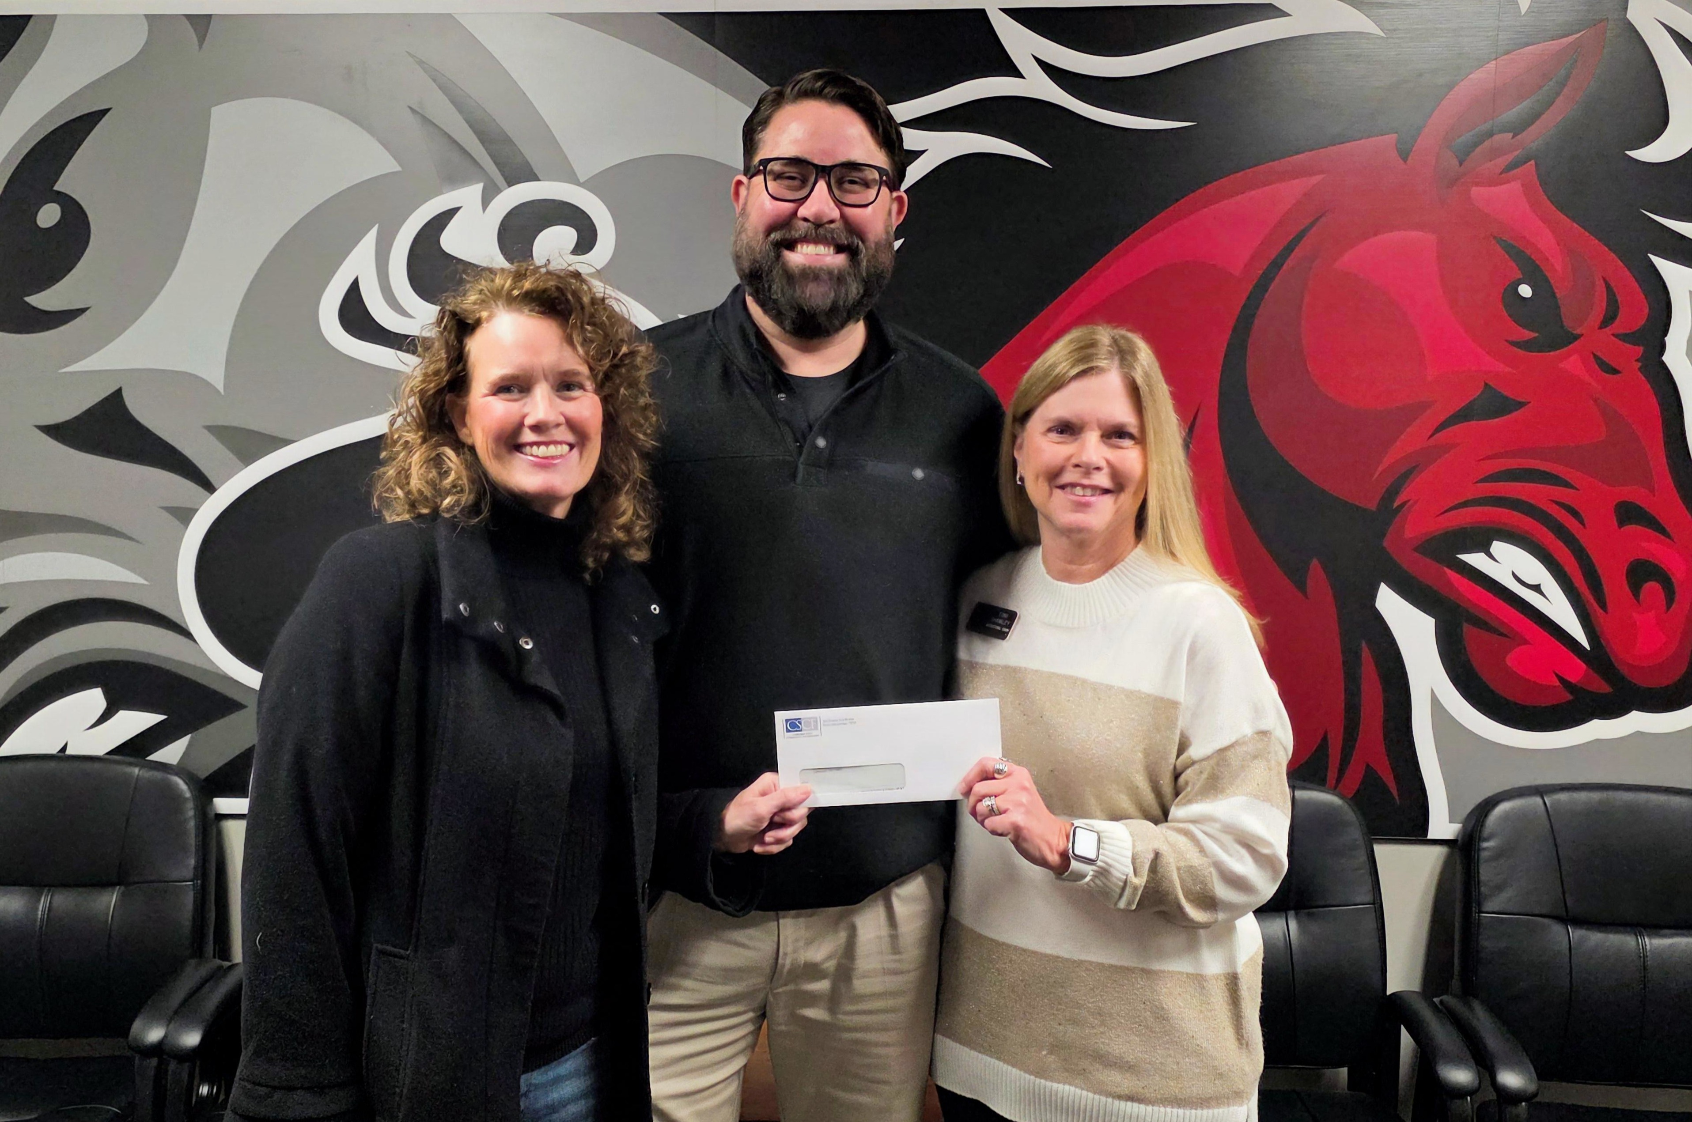
Hallie Caldwell (left), chair of the Cherokee Strip Community Foundation Grant Selection Committee, presents the foundation’s annual grant award to Longfellow Middle School Principal Jonathan Mitchell and Great Expectations instructional coach Toni Shamley. The grant will enable an LMS teacher to attend the Great Expectations Institute. Thirteen recipients were chosen as recipients of this year’s annual awards.

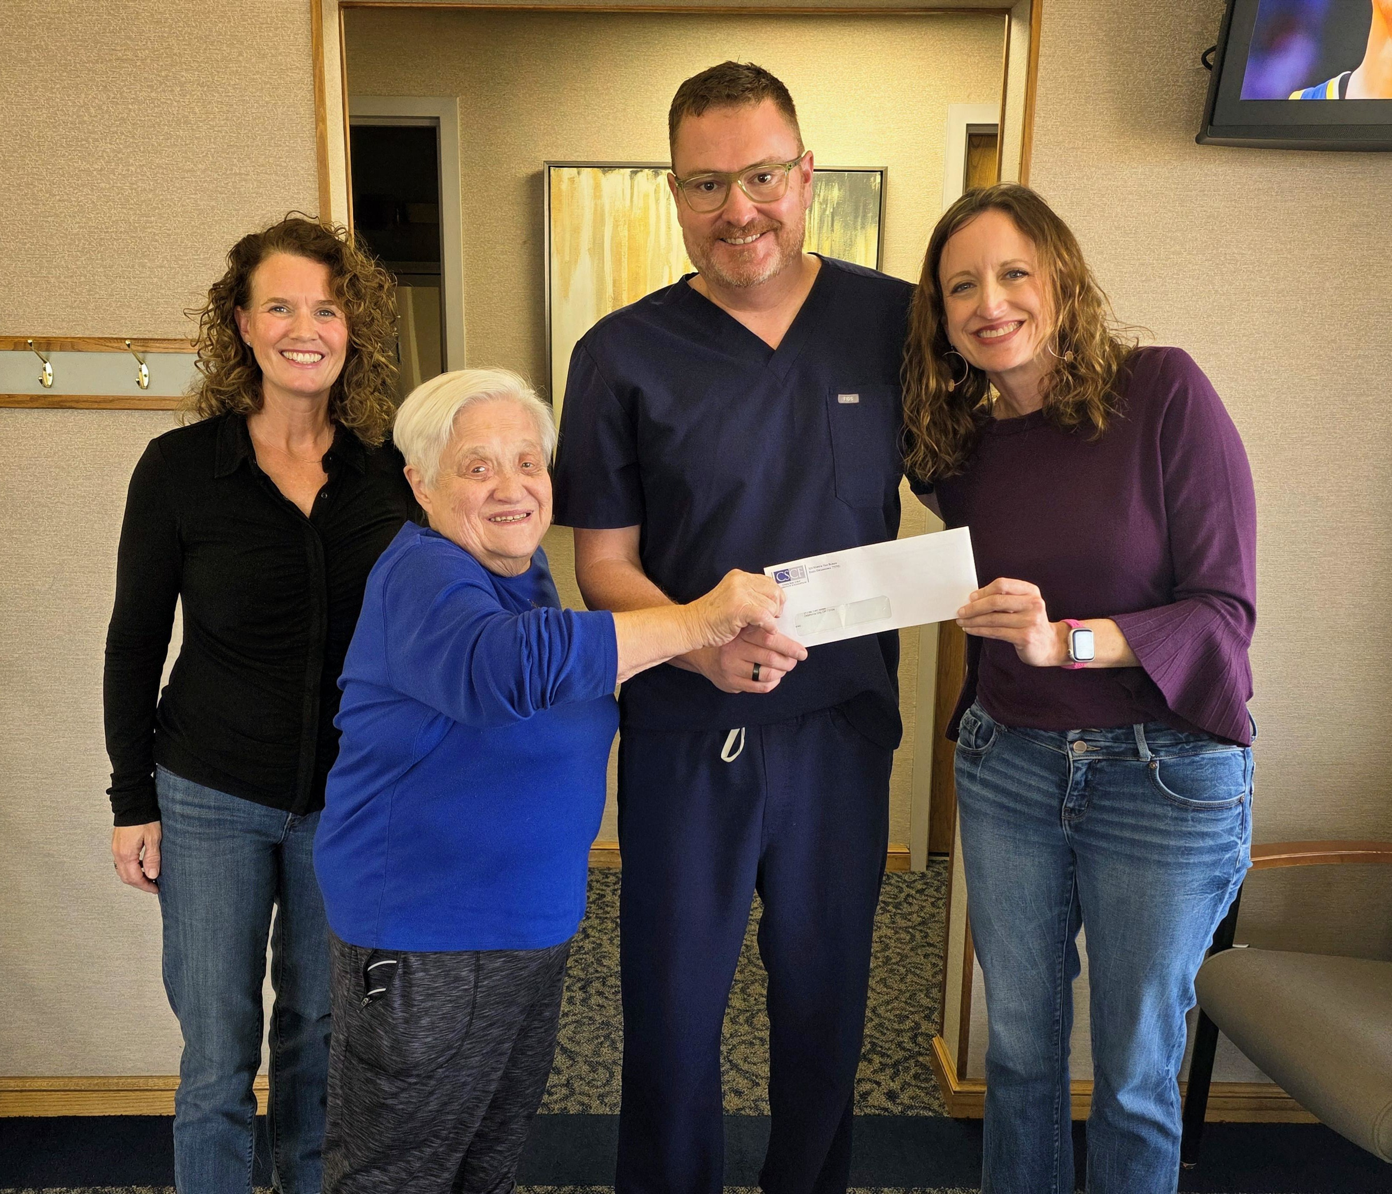
Pictured left to right are: Hallie Caldwell, chair of the Cherokee Strip Community Foundation (CSCF) Grant Selection Committee; Janet Cordell, Oklahoma Mission of Mercy (OkMOM) organizer; Dr. Chris Fagan, OkMOM Chair and organizer; and Jessica Caruthers, CSCF Board Chair. Caldwell and Caruthers presented the foundation’s annual grant award to the Oklahoma Dental Foundation for the Oklahoma Mission of Mercy (OkMOM), a free dental care event to be held in Enid at the Stride Bank Center on February 6-7. Thirteen recipients were chosen as recipients of this year’s annual awards.

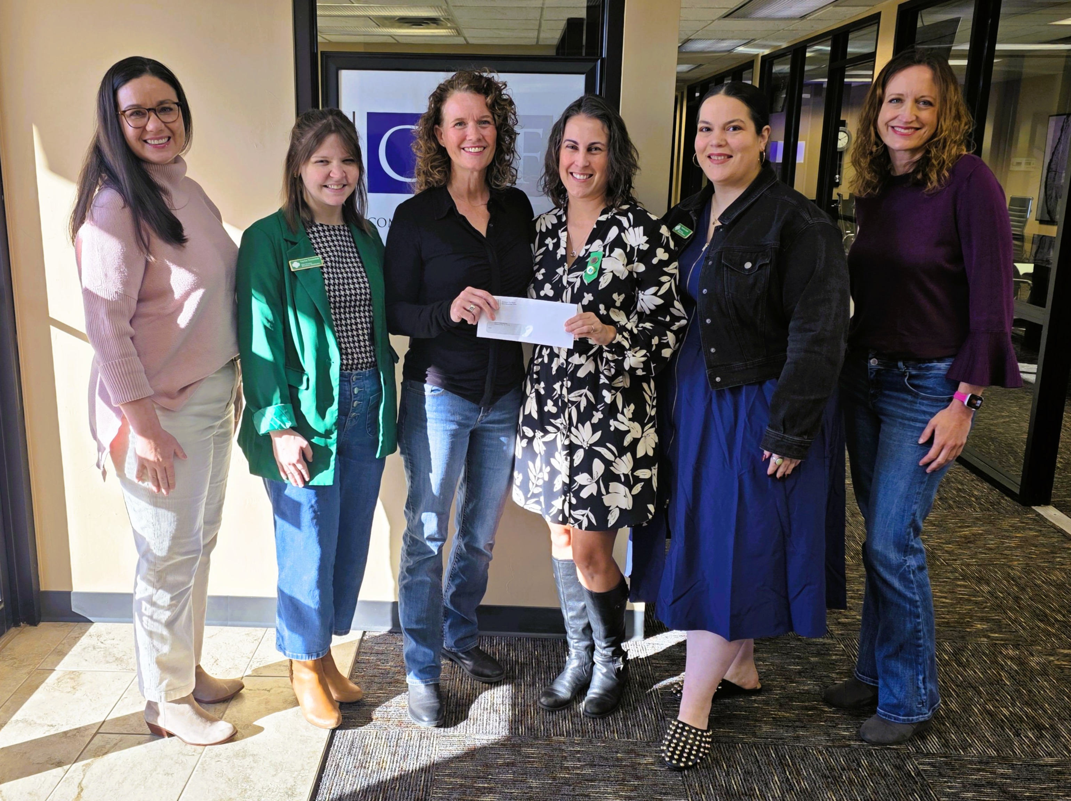
Pictured left to right are: Carrie Sanders, Executive Director of the Cherokee Strip Community Foundation (CSCF) Jessica Lamb, Resource Development Director, Girl Scouts of Western Oklahoma; Hallie Caldwell, CSCF Grant Selection Committee Chair; Gina Angileri-Lange, Girl Scouts of Western Oklahoma Unit Co-Manager and Troop Leader; Taylor Trousdale, Girl Scouts of Western Oklahoma Proposals and Partnerships Manager; and Jessica Caruthers, CSCF Board Chair.

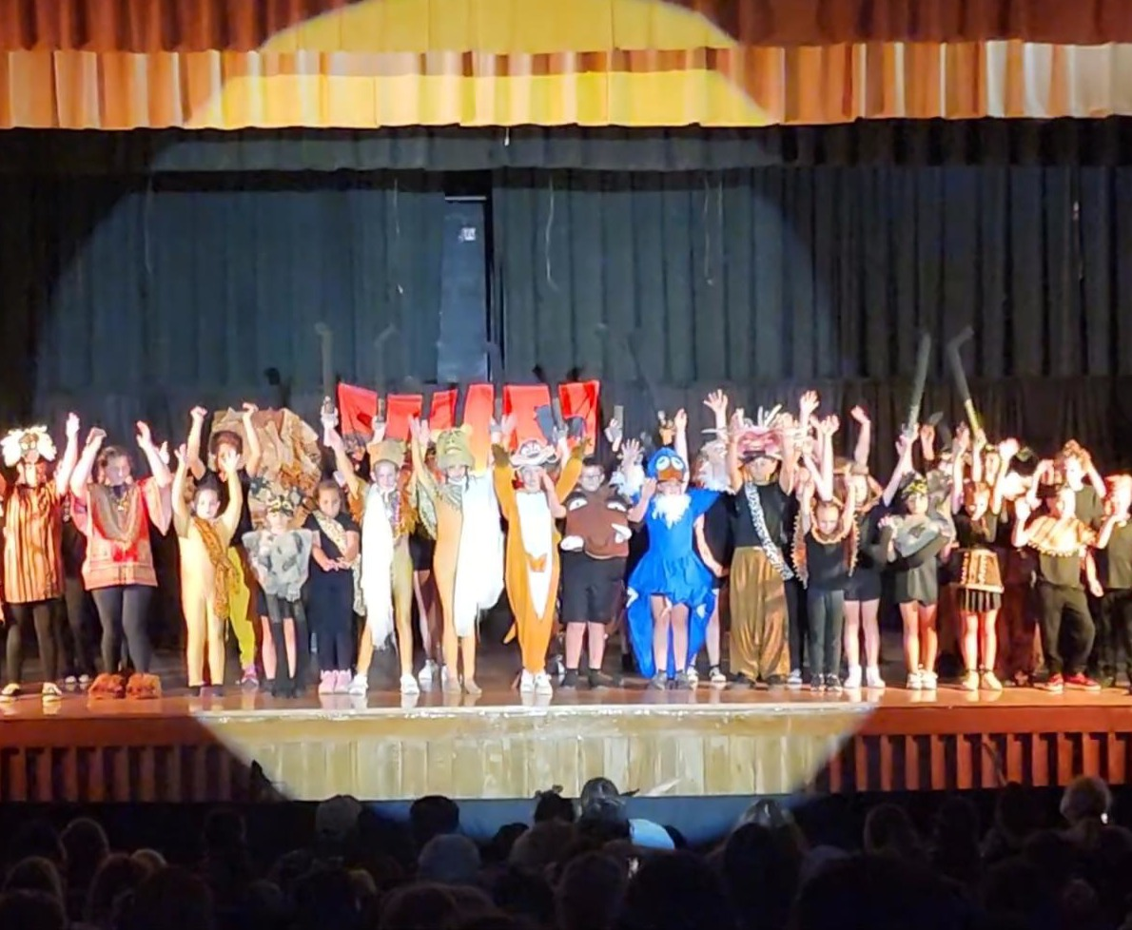
On Stage Woodward received Cherokee Strip Community Foundation funding in 2024 and 2025 to help promote youth engagement in theater. Pictured is the On Stage Woodward youth participating in a production of The Lion King in 2024.

